**Day 9 Assignment - 13/12/2023 - Vamsi Viswanadham**

**Conditional Statements:**

**If-Else Statement**: It is used to execute a block of code if a specified condition is true. If the condition is false, another block of code can be executed using else.

Eg:

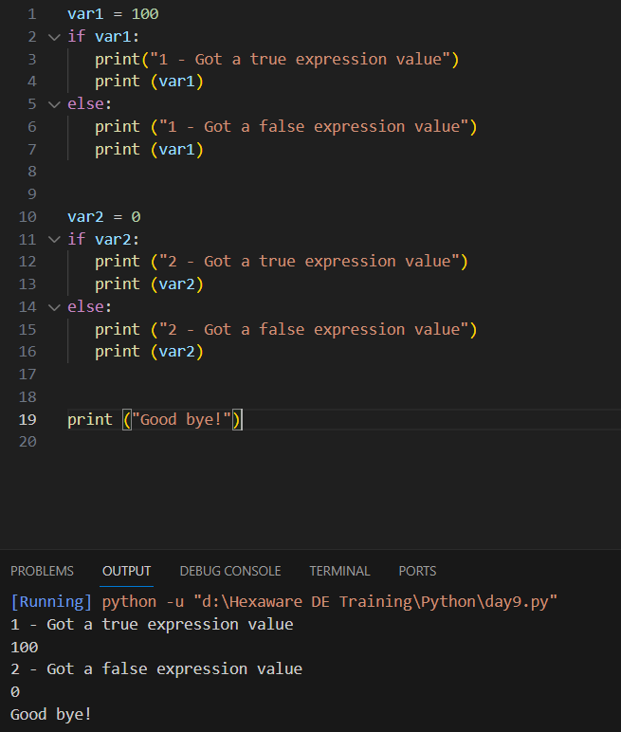

Here since var1 = 100, since it is a value, it is considered as True, so first if block gets executed, and var2 value is set to 0 so it is considered as false, so for the second if-else block, the else block gets executed. Finally the last print statement gets executed.

**Elif:** An abbreviation for 'else if', it allows for multiple conditions to be checked in sequence.

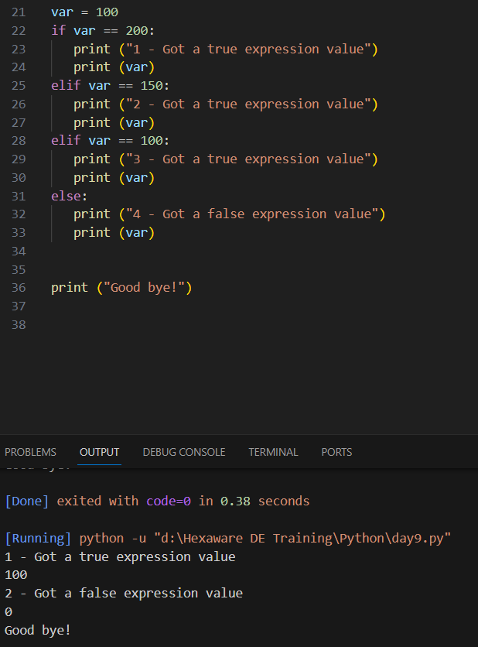

**Nested If:** Involves if-else blocks inside other if-else blocks, allowing for more complex conditional structures.

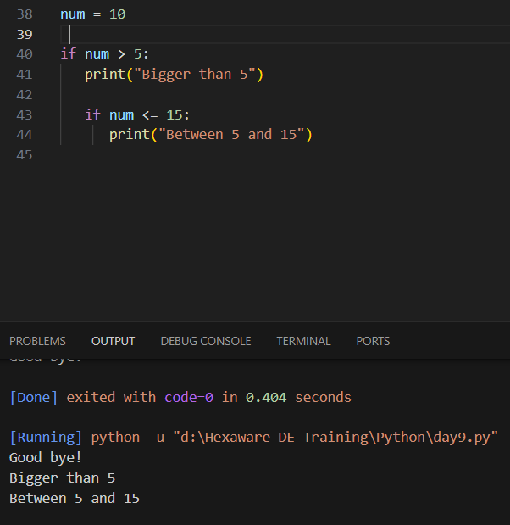

Here since the variable value is 10, first it enters into first if statement and then the second if statement too gets executed.

**Loops:**

**For Loop:** Used for iterating over a sequence (such as a list, tuple, dictionary, set, or string). It executes a block of code for each item in the sequence.

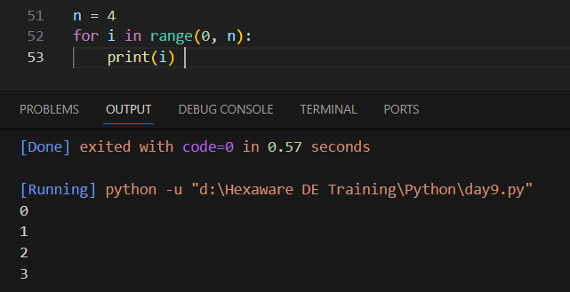

Here the for loop takes the range from 0 to 4 and thus print those 4 values starting from 0 to 4.

**While Loop:** Continuously executes a block of code while a given condition is true. The loop breaks once the condition becomes false.

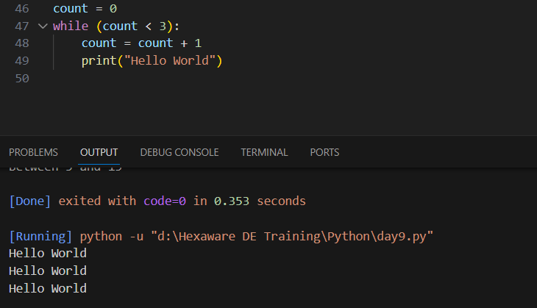

Here while loop gets executed three times and print the Hello World three times, since the loop stops when the count variable value reaches 3.

**Nested Loops:** A loop inside another loop. The inner loop will finish all of its iterations before the outer loop completes a single iteration.

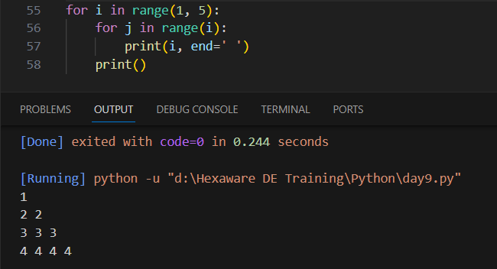

Here the first for loop gets executed from i value from 1 to 5, and for each i value the j value takes upto i values and print the j value by updating each variable by 1 in each increment.